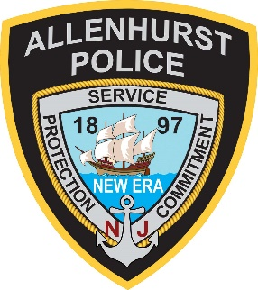 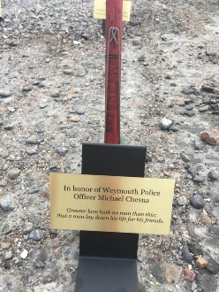 Forever Flare sample
ALLENHURST POLICE ASSOCATION
is proud to present:
ALLENHURST BEACH ILLUMINATION
SUNDAY AUGUST 20, 2023
Remember, Honor, Celebrate

Forever Flare

Sponsor a Forever Flare for $300 and it will be lit each year during our Allenhurst Beach Illumination.
Your Forever Flare will be placed in a special holder inscribed with your memorial. Your Forever Flare will be lit each year that we host the Allenhurst Beach Illumination.

PLEASE COMPLETE AND RETURN THIS FORM WITH PAYMENT TO:
Allenhurst Police Association, 125 Corlies Avenue, Allenhurst NJ 07711

Name: ____________________________________Address:_________________________________________

City: ______________________________________ State: ______ Zip:_____________ Phone: _____________

Email: ___________________________________ # of Flares: ____________($300 each) Total: $___________

Please print the message that you would like to appear on the lines below. Each line has a limit of 25 characters, including spaces between words/characters.

1st ___ ___ ___ ___ ___ ___ ___ ___ ___ ___ ___ ___ ___ ___ ___ ___ ___ ___ ___ ___ ___ ___ ___ ___ ___

2nd ___ ___ ___ ___ ___ ___ ___ ___ ___ ___ ___ ___ ___ ___ ___ ___ ___ ___ ___ ___ ___ ___ ___ ___ ___

3rd ___ ___ ___ ___ ___ ___ ___ ___ ___ ___ ___ ___ ___ ___ ___ ___ ___ ___ ___ ___ ___ ___ ___ ___ ___

Your commemoration will also be posted on the Borough of Allenhurst website

